Nathan Gebremichael
Final Project Executive Summary
Dr. Lois Jordan
Sunday April 19, 2026

Define: Kennesaw Community Hospital (KCH) is facing issues regarding long emergency department (ED) wait times. These issues include patient dissatisfaction, decreased revenue and negative reviews/bad reputation. KCH originally hypothesized an average wait time of about 200 minutes with no supporting evidence to back their claim. We aimed to break down and analyze KCH’s ED wait time data and if necessary, decrease the amount of time that patients have to wait. No more than 10% of patients should have to wait more than 4 hours to be either discharged or admitted into the hospital.

Measure: To accurately capture current circumstances, a sample of 300 patients was collected over the span of two weeks using systematic sampling. KCH expects about 3000 patients biweekly, therefore we assessed every 10th patient’s wait time. We want to collect our own data because it is likely the most accurate way to collect the data, we would have a better understanding of the process, and we also want a reliable baseline to test against when the time comes. Assessment of the data revealed that the hypothesized average wait time of 200 was inaccurate. In fact, we are 95% confident the true average ED wait time falls between 272.399 and 281.259 minutes, meaning patients were waiting significantly longer than KCH initially thought. We also found best case and worst-case scenario proportions for people waiting longer than 4 hours. The true proportion of people having to wait longer than 4 hours is currently between 79.67% and 85.54%. In addition to estimating the average wait time, also analyzing the proportion of patients waiting longer than 240 minutes provides us with a firmer analysis of the observed ED wait times. The results showed that even the best-case scenario estimate, the percentage of patients exceeding 240 minutes was significantly higher than KCH’s target of 10%, further confirming that some improvements were necessary.

Analyze: We needed to find exactly what was causing the inflation in ED wait times, and exactly how much improvement we needed to make to meet KCH’s needs. For the case to be that no more than 10% of patients are waiting more than 4 hours, our average wait time couldn’t exceed 189.89 minutes. Originally it was a staffing concern, we hypothesized that there were not enough doctors and nurses to tend to KCH’s patients. This would generally increase wait times, but 3 years ago KCH performed a similar test which led to a major staffing increase for doctors and nurses in the hospital. We took the data from 3 years ago and compared it to the data we collected on the reasons for delay for our 300 patients. A Chi-Square Goodness of Fit test was performed, and we discovered that there is a statistically significant difference in the distribution delay reasons. The staffing increase affected the pattern of the reasons for delay. It was unlikely that doctor and nurse availability was the primary cause of delays. In our sample, bedroom availability was the leading cause of delays. If housekeeping is unable to keep up with the delay of rooms, it would create delays in the ED. We observed the rate of demand for rooms in the hospital vs the rate at which housekeeping is preparing the rooms for occupancy. There was a 0.06% chance that the demand for rooms would exceed the rate at which housekeeping was cleaning them, therefore it is extremely unlikely that the issue lies within housekeeping’s ability to keep up with the turnover of rooms. This finding is important because it eliminates housekeeping capacity as the primary cause of delays in our system. Since the cleaning rate is more than sufficient to meet demand, the delays must be caused by a factor elsewhere in the process. This discovery allows KCH to focus on process improvements rather than increasing staffing or resources unnecessarily.

Improve: Based on our current analysis, there is a lot of room to improve within the bedroom sector, which accounts for about a third of the delays in our sample. After some research, it was found that KCH previously purchased an app that tracked housekeeping. They were able to notify hospital staff when rooms were ready, rather than having to manually check which rooms were available. After a management change it wasn’t being utilized. Before suggesting any alternative solutions we decided to test the one we already had. We collected a new sample of 300 patients after implementing the application. An ANOVA along with confidence intervals were assessed to compare the means and detect statistically significant differences. We found that there was a statistically significant difference in the true means after the implementation of the app. After implementation, we are 95% confident that the true mean ED wait time is between 174.21 and 182.82 minutes. We also checked to see if the variance was statistically significantly different. Through an F-test and a confidence interval on variances, we found that there was no statistically significant difference in the variances before and after the application took effect.

Control: Now that our average ED wait time is below the target wait time, we know that no more than 10% of KCH’s patients are waiting more than 4 hours. We need to make sure the solution lasts a long time. Six months later, we return to see if the average ED wait times are still below our threshold. Another sample of 300 patients was observed and compared with an ANOVA. With a slightly higher average, we observed no statistically significant difference between the average ED wait times of the improve and control stages, but they were both respectively statistically significantly lower than the original 300 patients. We can conclude that the implementation of the app has worked and decreased KCH patient’s wait times significantly, well below the originally hypothesized 200 minutes.

Conclusion: Overall, KCH patient’s average ED wait times should now be significantly shorter. No more than 10% of patients should have to wait more than 4 hours, which meets the goal of KCH.

PROJECT QUESTION #1:
ED patients think that they are waiting too long. Is KCH correct about their average ED wait time being only about 200 minutes? If it is higher, what can be done to make it so that at most 10% of patients wait longer than 240 mins?

PROJECT QUESTION #2:
We want this sample to be as representative of the sample as possible. Different nurses, receptionists, times of day, doctors, etc. If we are collecting data for 2 weeks and they get approximately 1500 patients per week, then during our collection period, KCH will receive approximately 3000 patients. We only need 300 so let’s use systematic sampling and collect data on every 10th patient. We want to collect our own data because it is likely the most accurate way to collect the data, we would have a better understanding of the process, and we also want a reliable baseline to test against when the time comes.

PROJECT QUESTION #3:
Business Question: How long can a patient typically expect to wait?
This question is important because we need to know how much of a delay (if at all) we’re dealing with. It shows how well the KCH is currently performing.
Statistical Analysis Tools Used: Confidence Interval on Average ED wait time. We want to calculate a range where we can be 95% confident that the population average is within said interval, to better grasp an idea of how long the average ED wait time truly is. The necessary statistics are displayed below.

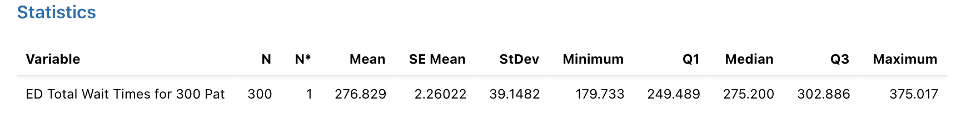

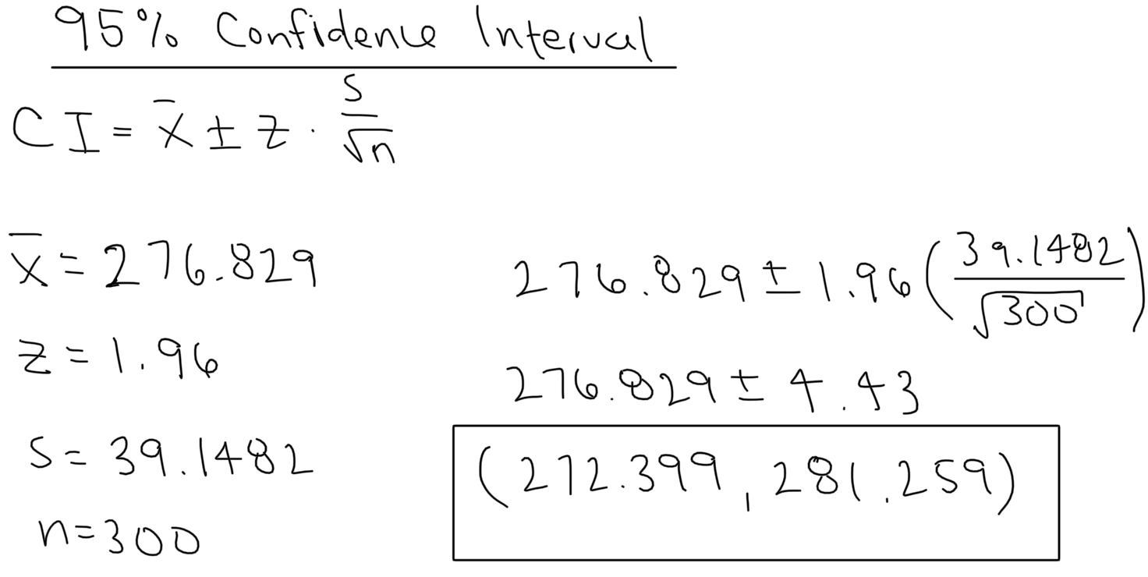

Statistical Analysis: We are 95% confident that the true average ED wait time currently lies between 272.399 and 281.259 minutes.
Business Conclusion: KCH patients can typically expect to wait between 272.399 to 281.259 minutes, which is more than the originally hypothesized 200 minutes.
PROJECT QUESTION #4:
Business Question: What % of patients are waiting more than 240 minutes? Does this meet KCH’s goal of less than 10%? We need to know our baseline amount of people having to wait more than 4 hours so that we can compare it to the sample after we implement some solution.
Statistical Analysis Tools Used: Z-score method and confidence interval
Statistical Analysis: We need to calculate the best case and worst-case scenarios for the proportion of people waiting longer than 4 hours.
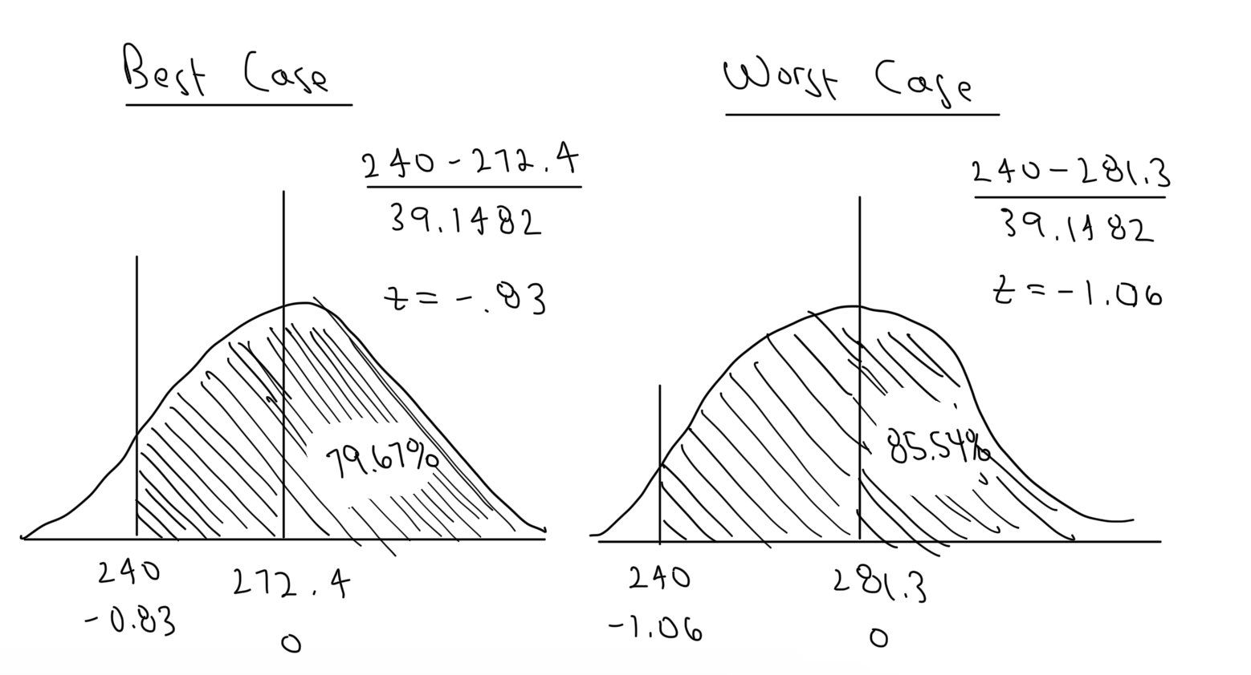
Statistical Conclusion: Using the associated areas under the curves on the z-table, the true proportion of patients waiting longer than 4 hours is between 79.67% and 85.54%.
Business Conclusion: KCH’s current performance does not meet their goal of only 10% of people waiting longer than 4 hours.
PROJECT QUESTION #5:
This data is based on our observed sample, which was 300 of our approximately 3000 total patients in the last 2 weeks. It is a possibility that we run into sample variation, and our sample is not as representative of the population as we thought. For example, it is possible that we selected significantly more patients that waited longer than 240 minutes than shorter than 240 minutes. This is why we cannot make a conclusion with 100% confidence.
A confidence interval is meant to give us a range of values that we can expect our statistic of interest to fall within. In this case we used a 95% level of confidence. For either statistic, I cannot give you an exact answer, especially with 100% confidence unless I have data on the entire population.
I know that these are the correct formulas to use because the lower bound is the shortest possible wait time we can predict with 95% confidence and the upper bound is the longest. If we test these means against our threshold of 240 minutes, we see that there is a certain percentage of patients that lie on each side of the threshold, which gives us our desired proportion.
Another way we can verify this is to look at our sample proportion. 246 out of 300 patients waited longer than 4 hours, which is 82%. This falls within our confidence interval for the proportion of people that waited more than 240 minutes.

PROJECT QUESTION #6:
Business Question: How many minutes would the average ED wait time have to decrease to for us to guarantee that no more than 10% of our patients are waiting more than 240 minutes?
This is important because we need to know the target wait time that we have to achieve to meet our goal of 10% or less of KCH’s patients waiting more than 240 minutes.
Statistical Analysis Tools Used: We want 240 minutes to be the 90th percentile for time spent waiting. In other words, we want the probability of a random patient waiting less than 4 hours to be 90%. We should use the z-score method with a cutoff of 240 to see the target wait time that we need to achieve.
Statistical Analysis: Since we want 10% of the data to be above the cutoff, we can use 1.28 as our z-score. If our hypothesized mean is at least 1.28 standard deviations lower than our cutoff, then it will be at most 10% of our patients waiting longer than 240 minutes.
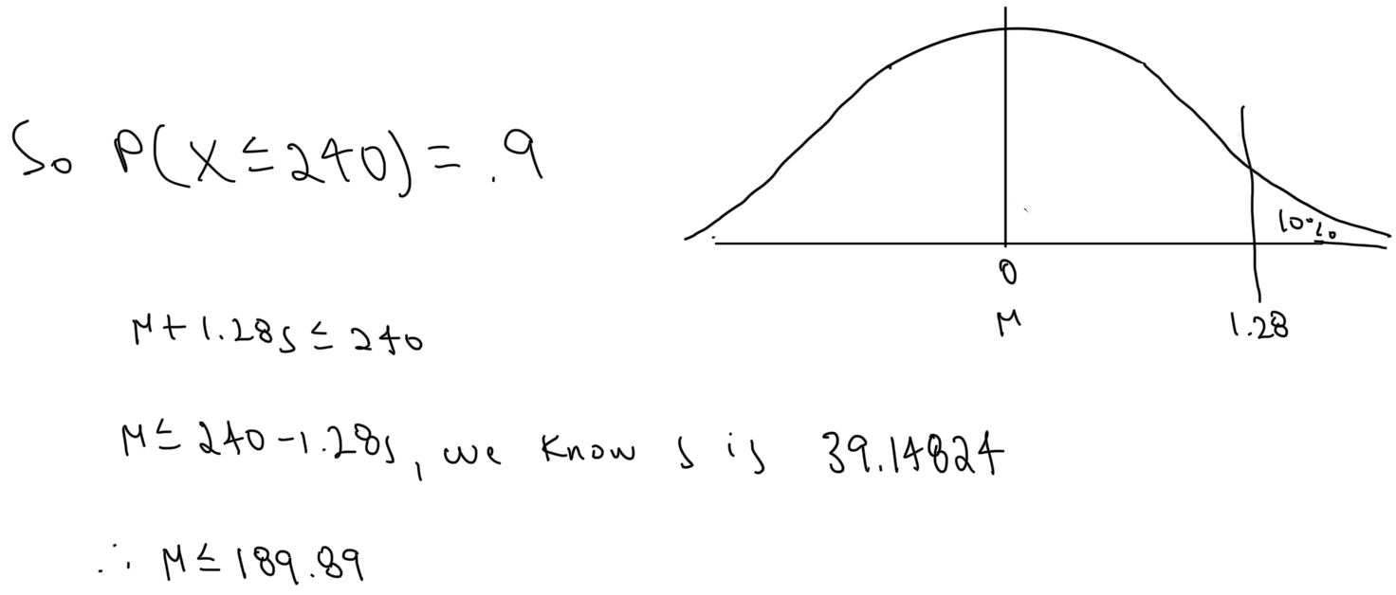
Statistical Conclusion: 240 minutes will be the 90th percentile of wait times if the average wait time is 189.89 minutes.
Business Conclusion: In order to ensure that no more than 10% of patients are waiting more than 4 hours, the average ED wait time would have to be 189.89 minutes. We now have a target average wait time and can see what implementations can be made to reach our goal.
PROJECT QUESTION #7:
Business Question: Did the staffing increase affect the pattern of the reasons for delay? We need to know if the staffing is still an issue, or if there is a different underlying reason as to why there are still delays.
Statistical Analysis Tools Used: Chi-Square Goodness of Fit Test. We use this test to compare our observed counts from today to what we expect, which would be similar proportion to 3 years ago.
Statistical Analysis:
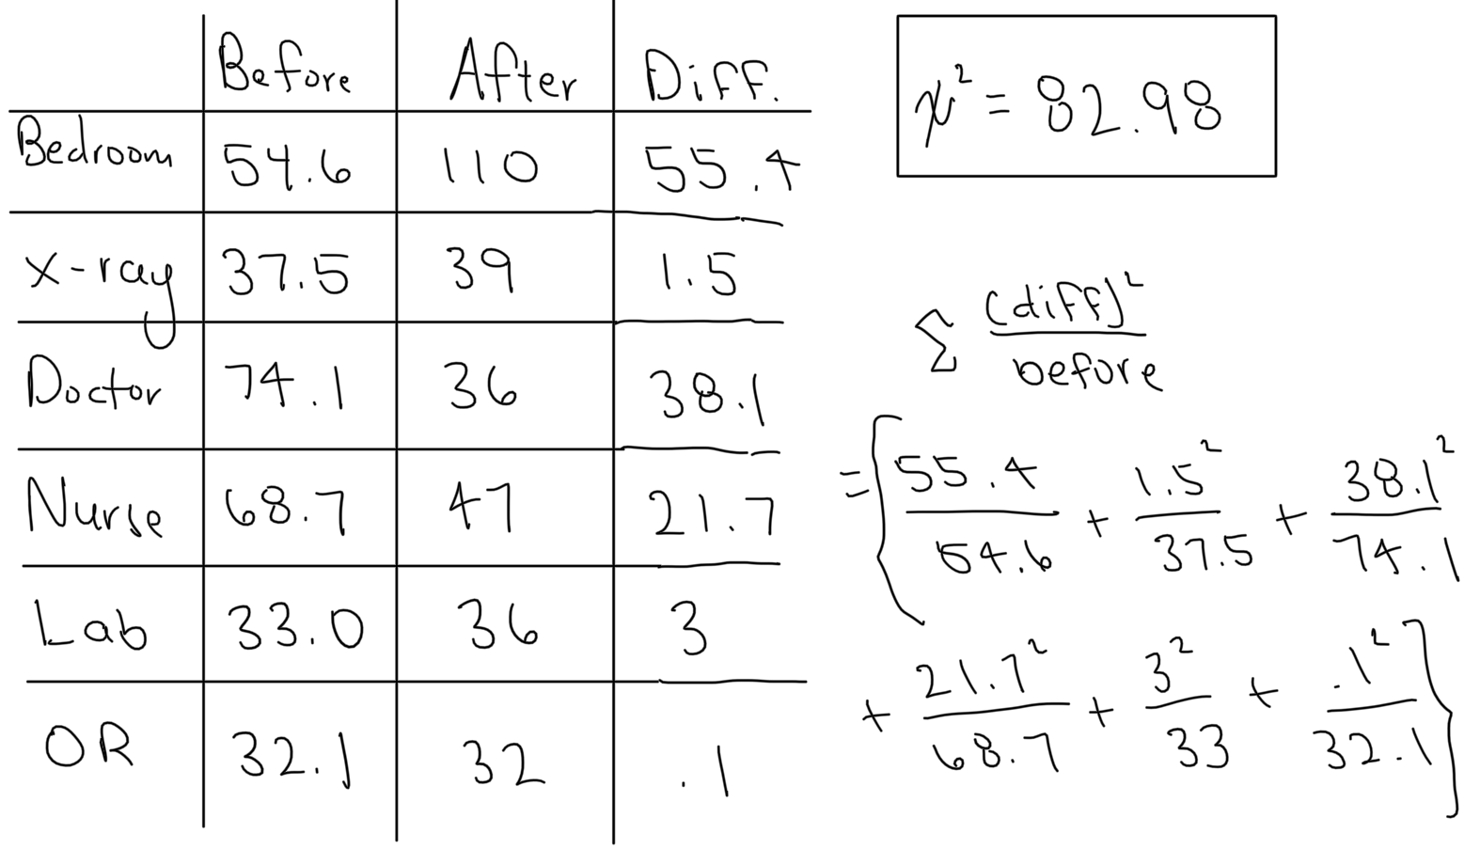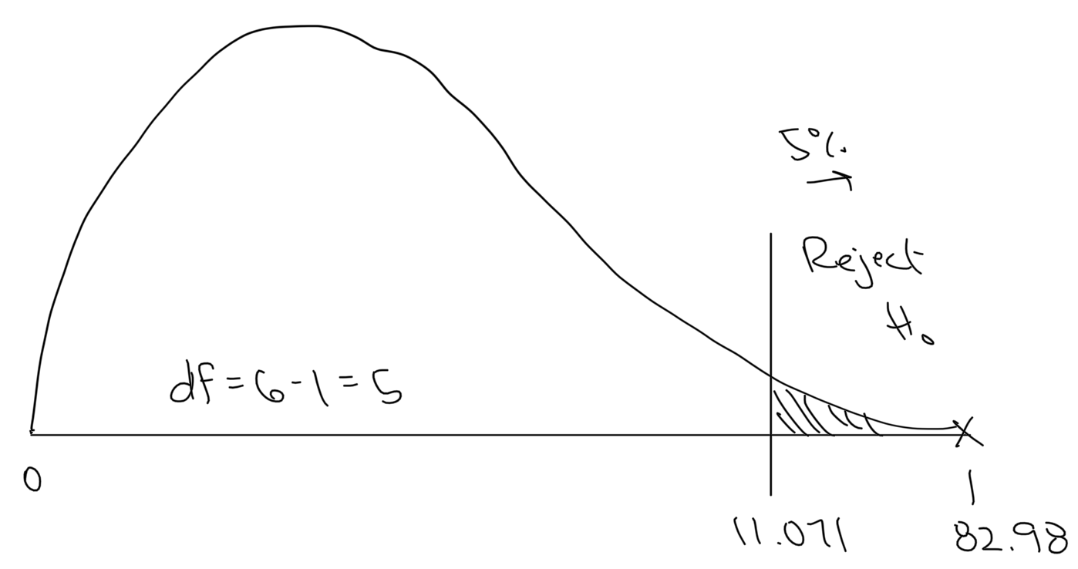
Statistical Conclusion: We are well beyond 95% confident that there is a difference in the distribution of the pattern of reasons for delay from before and after the staffing increase.
Business Conclusion: Yes, the staffing increase affecting the pattern of the reasons for delay. We should observe and analyze the new leading reason.

PROJECT QUESTION #8:
Business Question: Can housekeeping keep up with the demand of rooms? This is important because if they can’t keep up, then that is likely the reason for the delays and a change needs to be made for average ED wait times to decrease.
Statistical Analysis Tools Used: Housekeeping can clean 4 rooms per hour, while 1.15 patients need to be transferred per hour. We need to know how often housekeeping will fail to keep up with the room demands. We can use Poisson distribution to see how likely it is that the demand for rooms stays below 4 rooms per hour.
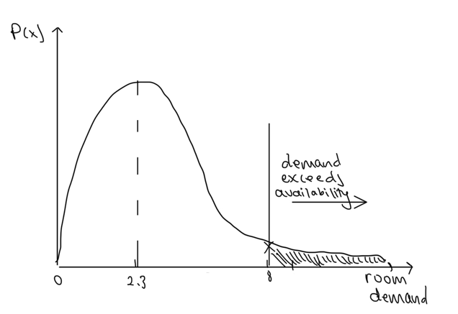
Statistical Analysis:
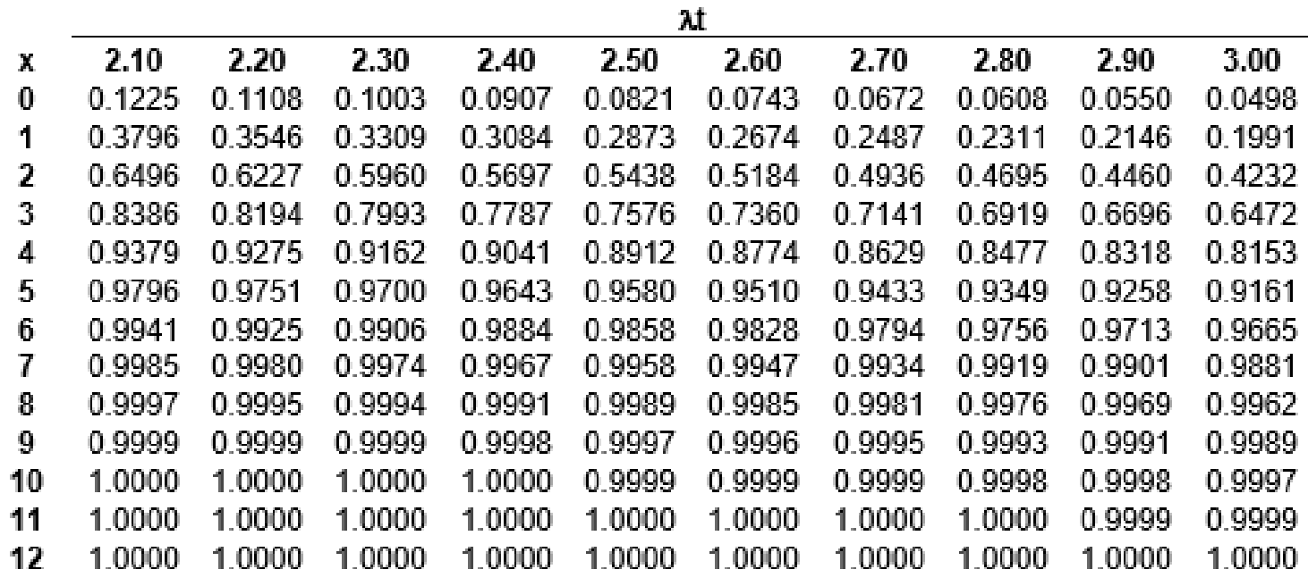
Statistical Conclusion: There is a 0.06% chance that the demand of rooms per hour ever exceeds housekeeping’s cleaning rate.
Business Conclusion: Yes, housekeeping can keep up with the demand of rooms. We can conclude that the delays are not due to housekeeping’s ineffectiveness.
PROJECT QUESTION #9:
Business Question: Has the overall average ED Total Wait Time has come down to the team’s goal for the average total ED wait time? Has the process variation stayed the same?
Statistical Analysis Tools Used: First I used a one-way ANOVA to compare the means. I next used a confidence interval and compared it the data prior to the app. To compare the variances, I used an F-test and confidence interval.
Statistical Analysis:
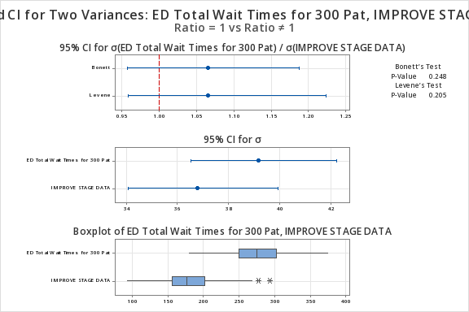
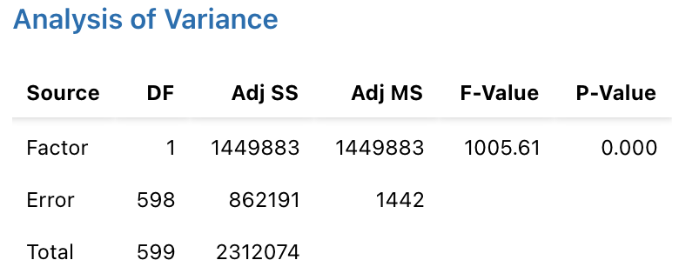
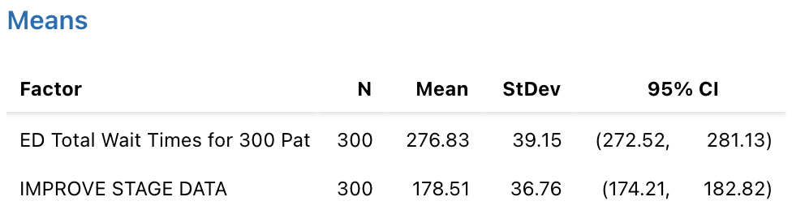
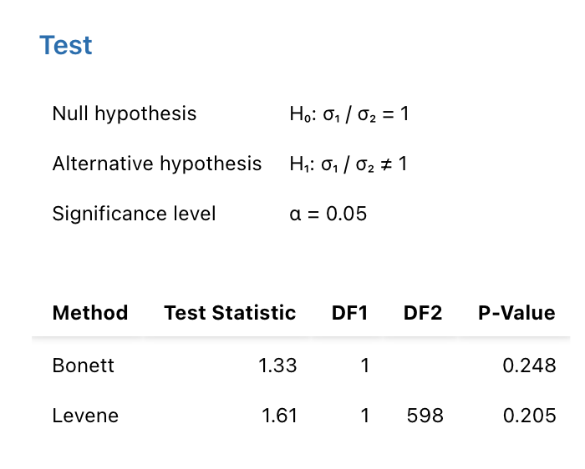
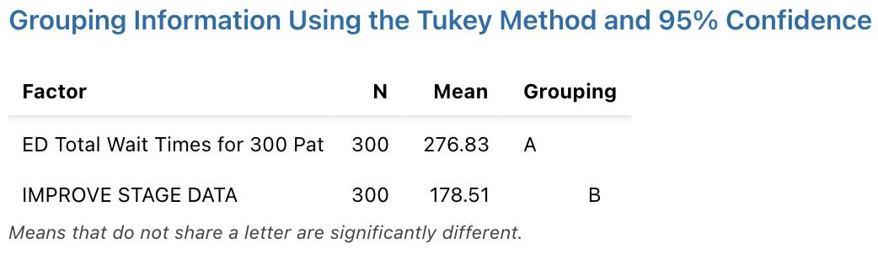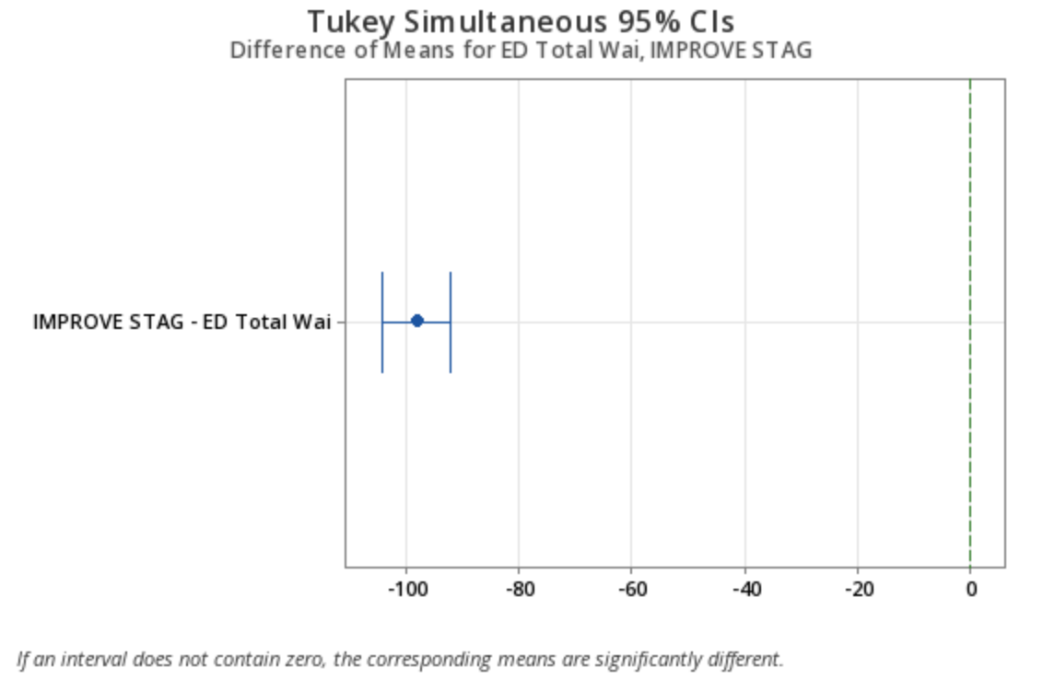

Statistical Conclusion: We are more than 95% confidence that there is a statistically significant difference in the true mean ED wait times before and after the implementation of the app. We also observed that there is no statistically significant difference in the population variances before and after the app took effect.
Business Conclusion: The overall average ED Total Wait Time has decreased below the team’s goal for the average total ED wait time. The variance remains unchanged even after the implementation of the app.
PROJECT QUESTION #10:
Business Question: Has there been a change in the average ED wait times after the implementation of the app, and has it been sustained?
Statistical Analysis Tools Used: We know that there was a difference after the app, now we need to make sure it was sustained, so we can run another ANOVA to see if there’s a difference between the improve and control stages.
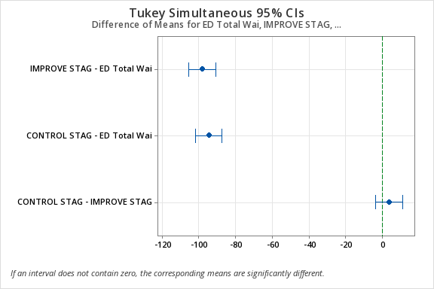
Statistical Analysis:
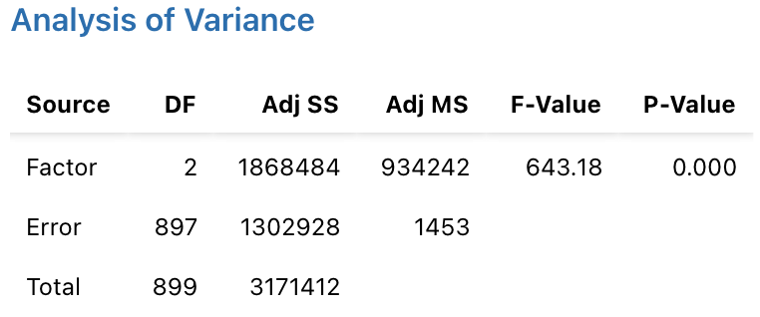
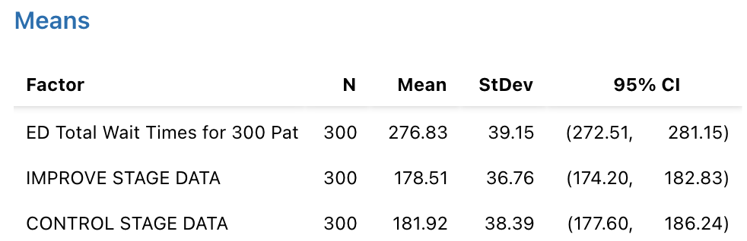
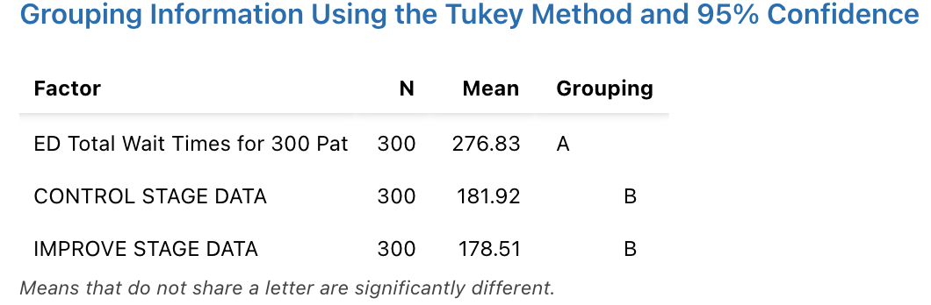

Statistical Conclusion: There is no statistically significant difference between the control stage and improve stage. But they are both statistically significantly lower than the original data, and we can conclude with 95% confidence that the true mean differences for both the control and improve stages are below our target average wait time of 189.89 minutes.
Business Conclusion: There has been a change in the average ED wait times and they are being sustained. As long as KCH continues to utilize their app, the average ED wait times should remain low.

